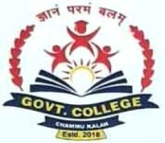

Govt.College Chammu Kalan Ismailabad

Kurukshetra (Haryana) 136129

Ph.01744-295291
Website-gcchammukalan.ac.in Email-gcchammukalan@gmail.com
STUDENTS
Students Enrolment for the Session 2022-23.
Class | Boys | Girls | Total
B.A =1st | 68 | 54 | 122
B.A=2nd | 31 | 36 | 67
B.A=3rd | 31 | 25 | 56
B.Com=1st | 17 | 07 | 24
B.Com=2nd | 02 | 04 | 06
B.Com=3rd | 14 | 05 | 19
Grand Total |  |  | 294

